WeeNAS
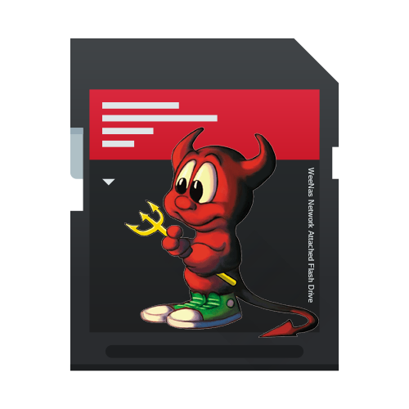
Admin Guide
This is an incomplete draft!
Day-to-day operation of your WeeNAS system.

Trademarks, Copyrights, and Disclaimers
The term Raspberry Pi is a trademark of the Raspberry Pi foundation. http://www.raspberrypi.org/
FreeBSD is a registered trademark of the FreeBSD foundation. https://www.freebsdfoundation.org/
Samba is a trademark of the Samba Project. https://www.samba.org/

The text of this document is copyright (c)2020 David Horton, and is made available according to the terms of the Creative Commons Attribution Share-Alike (BY-SA) 4.0 license. https://creativecommons.org/licenses/by-sa/4.0/

The source code of the WeeNAS API and its utilities are copyright (c)2020 David Horton and are made available under the conditions of the Simplified BSD license. See License.txt in the root of the WeeNAS software package.

Your data is important to you. You, and only you, are responsible for safeguarding it against loss. Using WeeNAS to store your data in no way removes that responsibility. Always maintain backups and have a recovery plan for when disaster strikes.

Accessing WeeNAS
Most administrative tasks can be performed using the web-based administration tool. Depending on the capabilities of your home network, you may be able to access it using a hostname, like this: https://weenas.local:9000/admin.html or, if hostname doesn’t work, you can use an ip address, like this: https://192.168.0.11:9000/admin.html
However you get there, you should see a login screen like this:
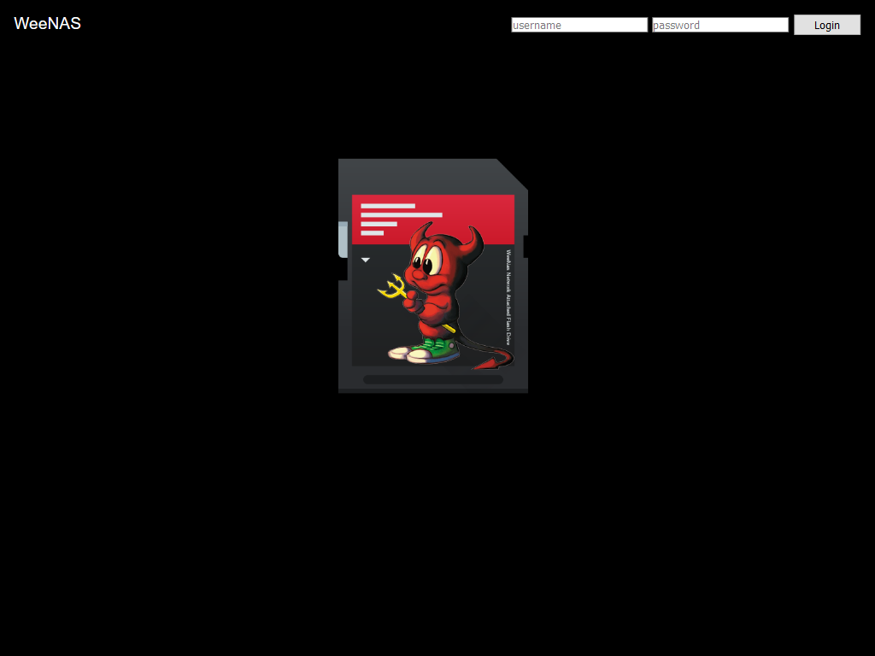
You’ll need to log in with the username/password of a user with admin privileges. Use freebsd/freebsd if this is your first time logging in.
Note: WeeNAS uses a self-signed encryption certificate. This requires you to add an exception to your browser for the WeeNAS admin page. For more information, see: https://support.mozilla.org/en-US/kb/error-codes-secure-websites#w_self-signed-certificate

The Welcome Page
After successful login, you’ll land here.
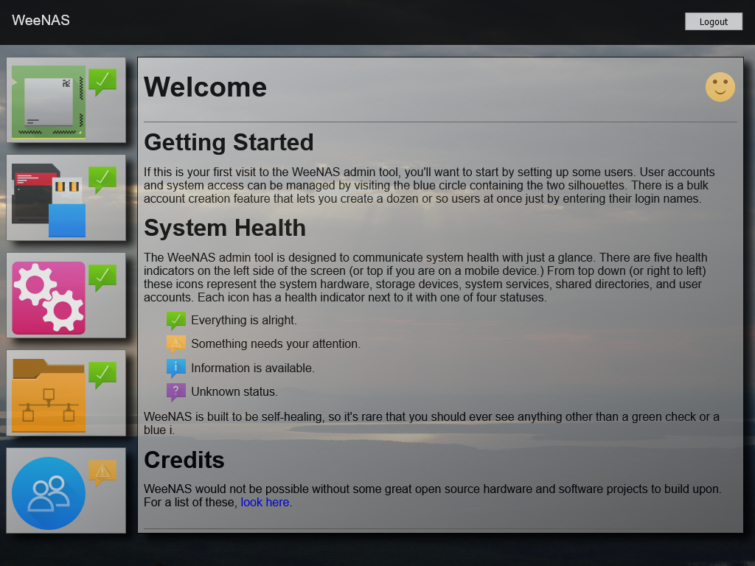
This is where you can view the health of your WeeNAS system.
The WeeNAS administration page will adapt itself to various screen sizes and aspect ratios. An example from a tablet in portrait orientation is show below.
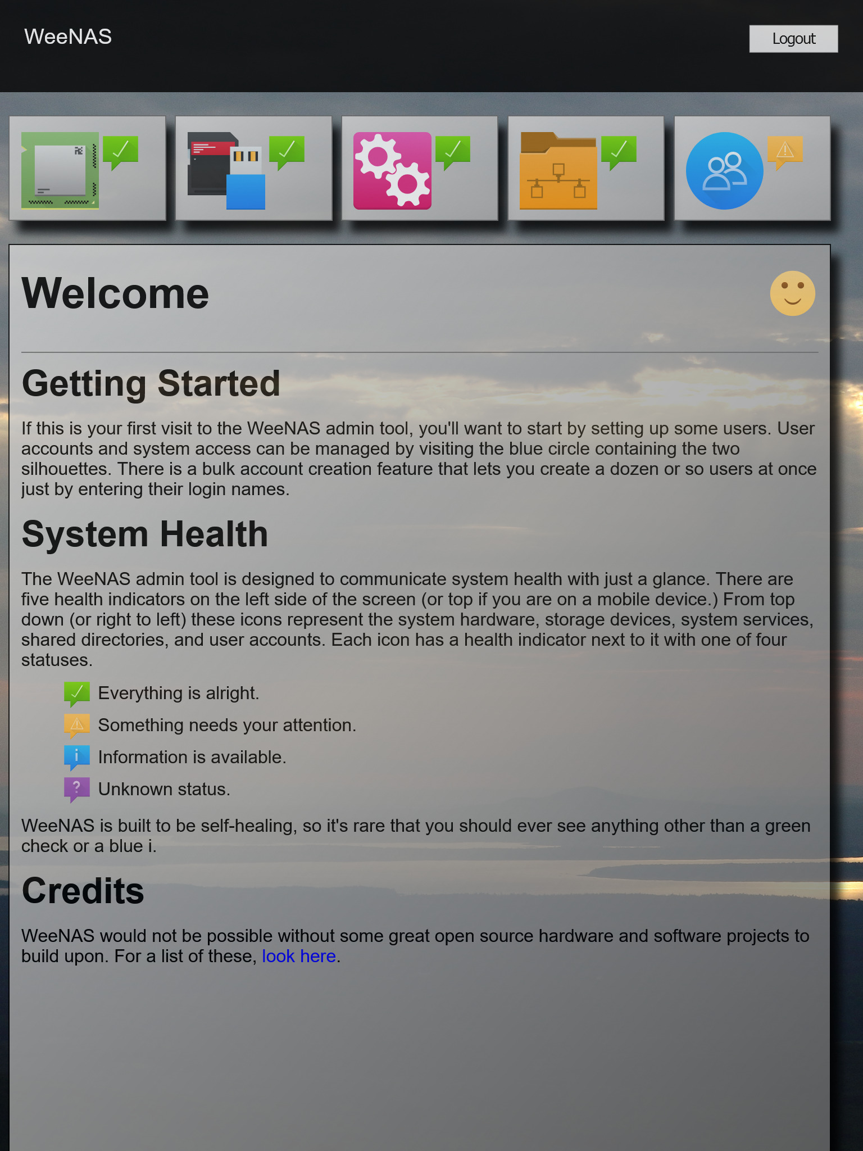
Notice how the icon run from left to right across the top of the page to optimize the viewable area. Regardless of where the icons appear, their functions are the same.
With devices like phones or anything smaller than a tablet, it’s best to turn the device sideways for a landscape view.
On the main screen, the five categories represented by the icons are:
- System – The Raspberry Pi hardware.
- Storage – Any mass storage devices like USB flash drives or the MicroSD card.
- Services – Operating system services.
- File Shares – Directories shared over the network.
- Users – Accounts and the privileges they have.
Each of these represents a piece of the WeeNAS system.
Next to each category icon is a summary health indicator. This can appear in one of four states and shows the overall heath of the category. The meaning of each indicator is detailed on the Welcome page.
You can navigate through administrative functions using the category icons. Each icon can be clicked (or tapped) to get a more detailed look at its health and the functions it controls.
Let’s start with a brief tour.

System
Clicking on the CPU icon gets us to the system details.
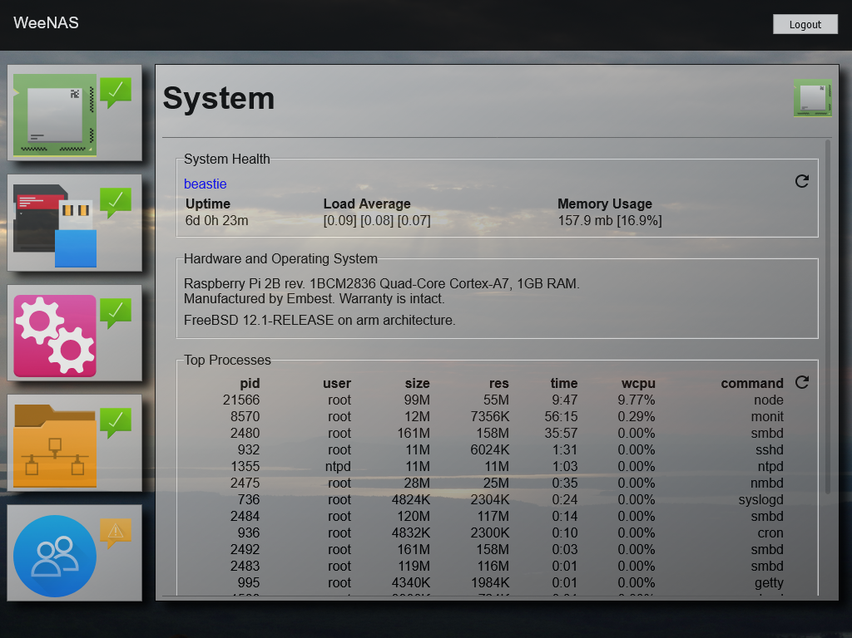
Here you can see an area called System Health that shows the hostname, details like system up time, load average, and memory usage.
There is also an area with information about the hardware and operating system followed by a list of processes and the resources being used by each one.
Note: Advanced users can get much of the same information from the FreeBSD command-line using the ‘top’ command.
Notice how the system hostname (toward the top) is shown in blue. This indicates a link that can be clicked for additional details.
Let’s follow the hostname link.
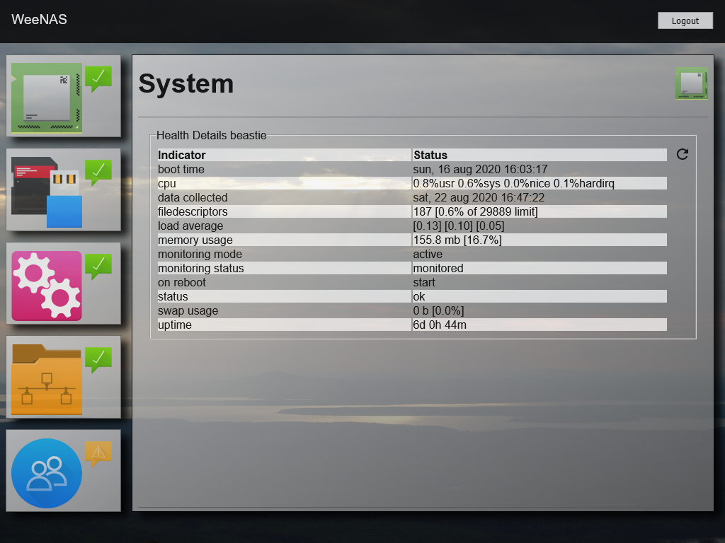
This brings up the most detailed view of the system. In addition to the indicators shown on the previous screen, we also see boot time, cpu usage, detailed memory usage, and more.
Note: These same details can be shown on the command-line using the command ‘monit status <hostname>’, where <hostname> is the name of the system.
There is also a circular arrow at the far right. You may have noticed this in a couple sections on the previous screen. Clicking the circular arrow will refresh the view for the section it’s in. It acts the same no matter what page you’re on.
Use the bowser’s back button or click/tap the system icon on the left to return from the detail view.

Storage
Clicking or tapping the SD-Card/USB Flash icon brings up status and details on the WeeNAS device’s filesystems.
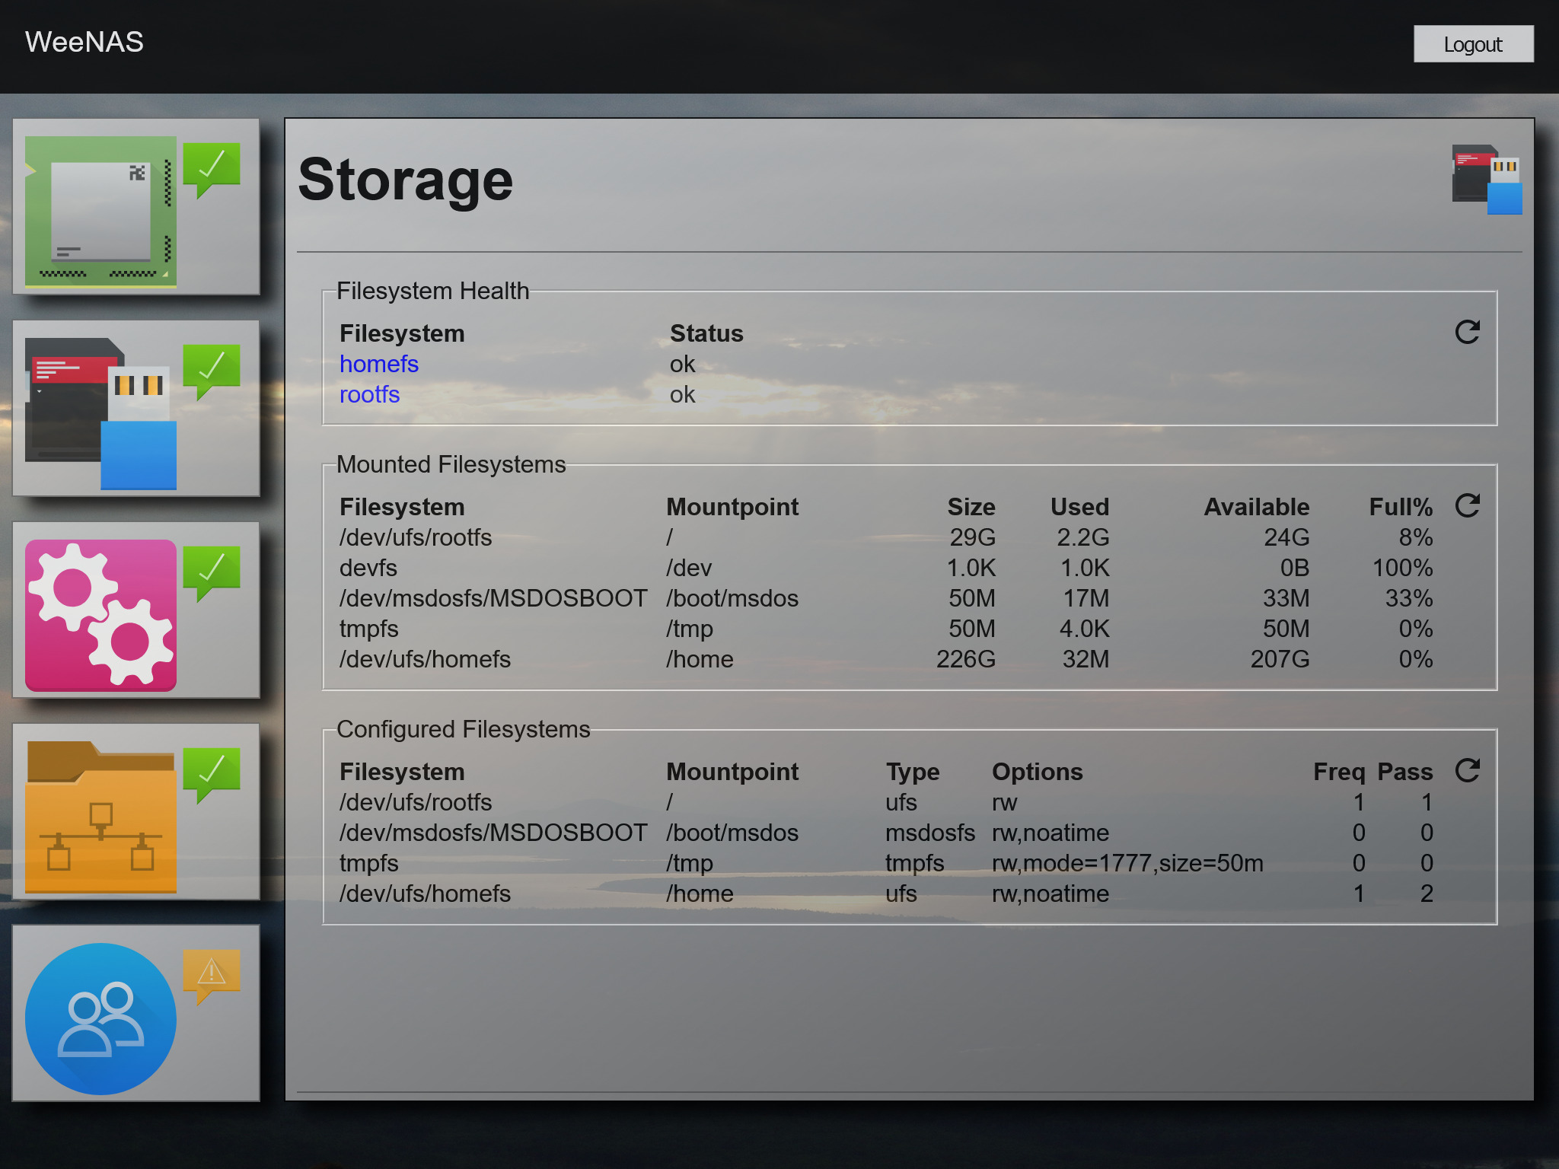
Each filesystem is shown along with a general health indicator of “ok”.
Individual filesystems are shown as blue links that can be followed for more detailed information. This is particularly useful if something other than “ok” is shown.
Note: Advanced users can access this same information using the folowing commands:
- monit summary <filesystem>
- df -h
- cat /etc/fstab
Any maintenance such as mounting, unmounting and fsck will also need to be performed using command-line tools.

Services
The icon with two gears lets you access the system services running on the operating system.
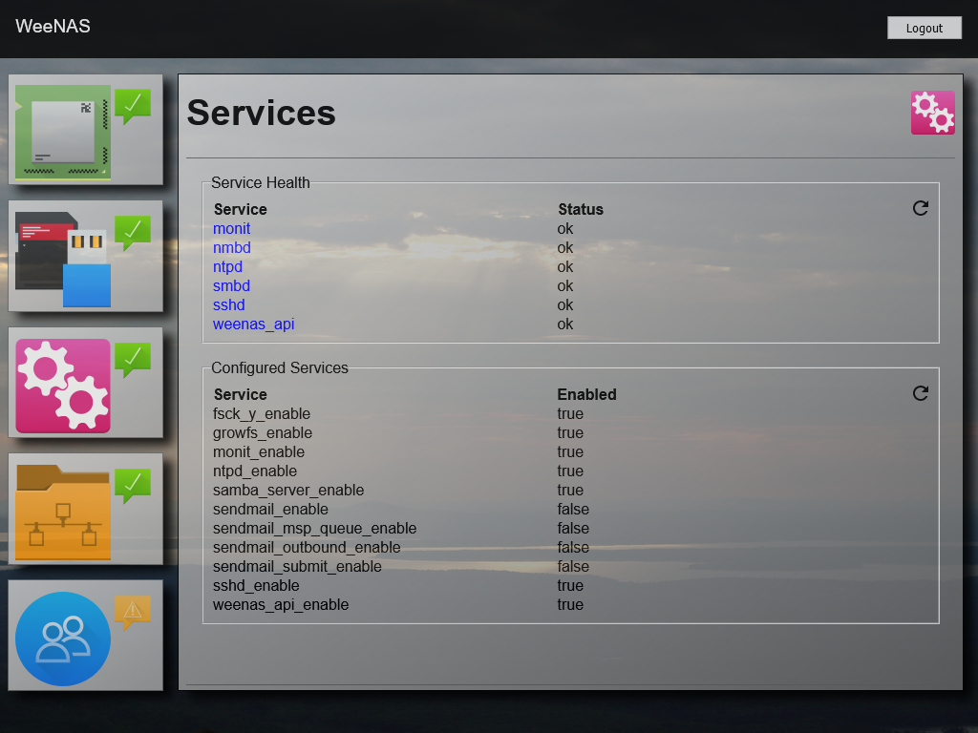
The services shown under the heading of Service Health are the ones critical to the operation of WeeNAS. Anything not in an ‘ok’ state should be investigated. (Notice the blue links indicating additional details are available.)
Also on this page is a list of configured services along with a true/false indicator showing them as enabled or not. Some of these will match the service health indicators above. These should all be enabled.
Note: This information is available on the command-line by using ‘monit summary’ and viewing the contents of /etc/rc.conf.
Other services, such as sendmail, are shown as disabled, because they were installed this way as part of the FreeBSD operating system. Advanced users can enable them if desired, but they will not be monitored by WeeNAS.

File Shares
Accessing the icon showing a network segment superimposed on a file folder brings up File Share information.
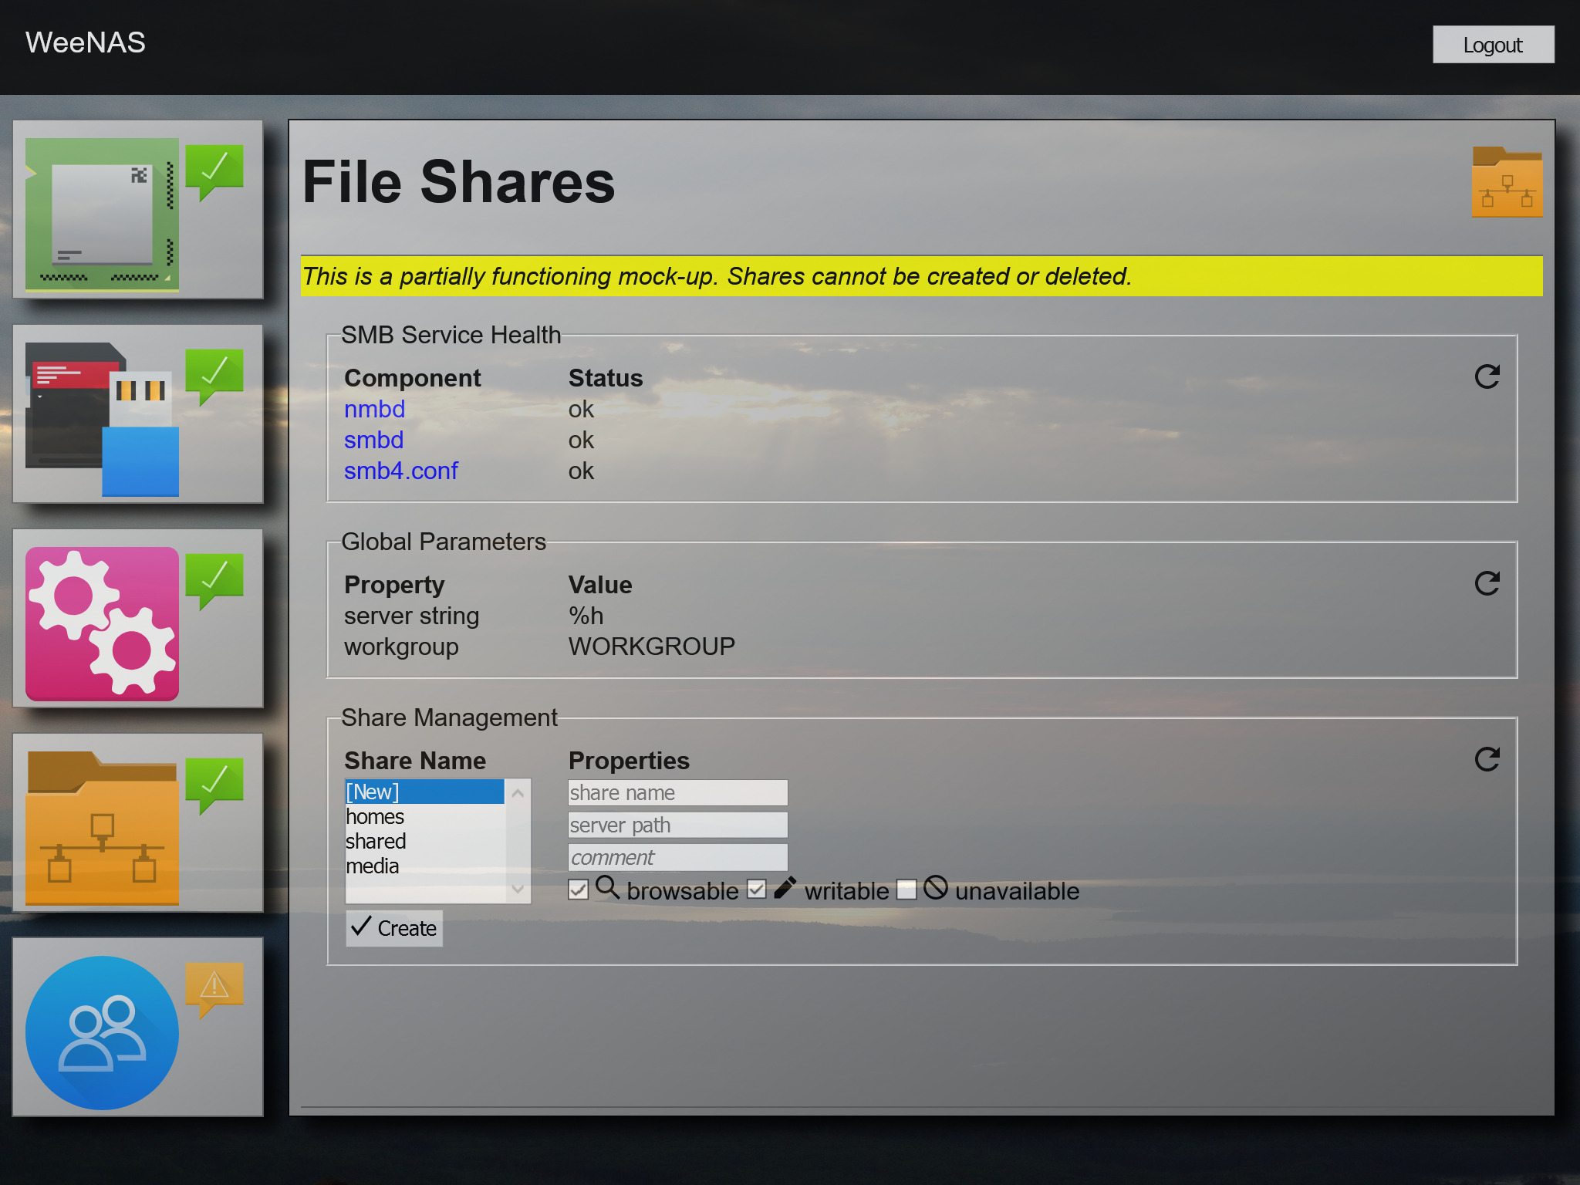
The health of file sharing (Samba) components is shown here along with the currently configured shares.
The shares created when WeeNAS was installed are shown. Clicking on any of the share names in the Share Management section will bring up additional details.
Note: At this time, all of the information is read-only and nothing can be created, updated, or deleted. Advanced users can edit /usr/local/etc/smb4.conf to make changes.

User Accounts
The blue circle with two human silhouettes is how you access user accounts.
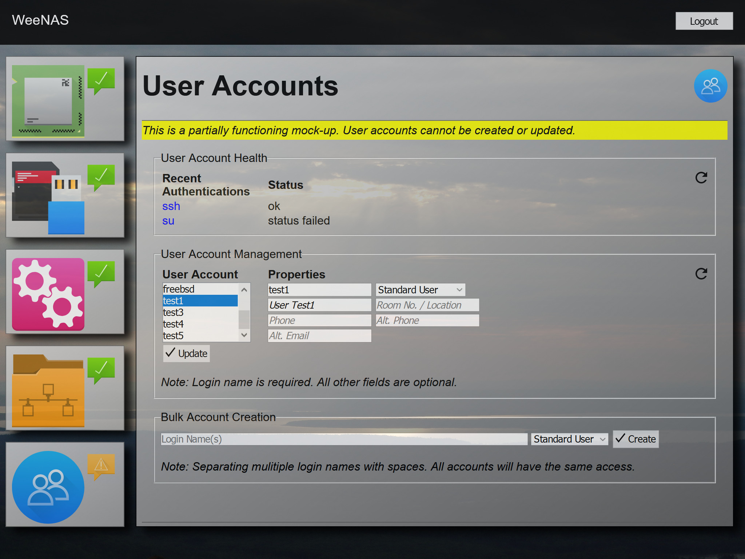
Recently failed logins are shown as indicators under User Account Health. Any failed ssh connections or su attempts are shown here. Failures will remain until the system logs rotate.
In the User Account Management section, account details are shown when the user’s login name is selected. Access to the system is simplified into categories of user, including Standard User, Power User, and Admin User as the most common.
Standard users can access file shares. Power users get file share access as well as the ability to log in via ssh. Admin users can do all of this and also su to root.
Be careful with giving out admin privileges.
There are also some non-standard combinations of privileges. The freebsd user will show “Admin (Shell Only)”. This account has the ability to log in via ssh and su to root, but cannot access any file shares. This privilege level is informational only and cannot be selected for new users.
Note: Creating users through the admin page is not complete at this time. In the interim, there is a command-line tool called createusers.sh.
The tool has a look similar to the installer.
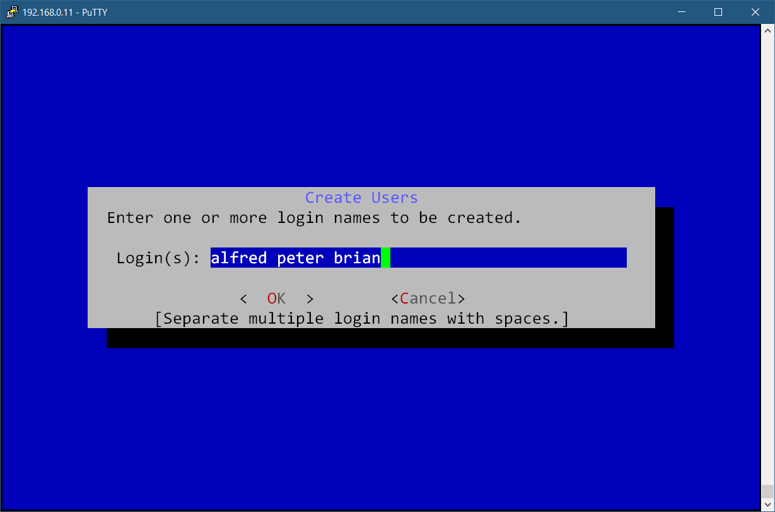
First, you will be prompted to enter one or more user account logins. Use lowercase names and separate the names with spaces.
Next, you will be asked a series of questions about access levels. The choices you make will be applied to all users.
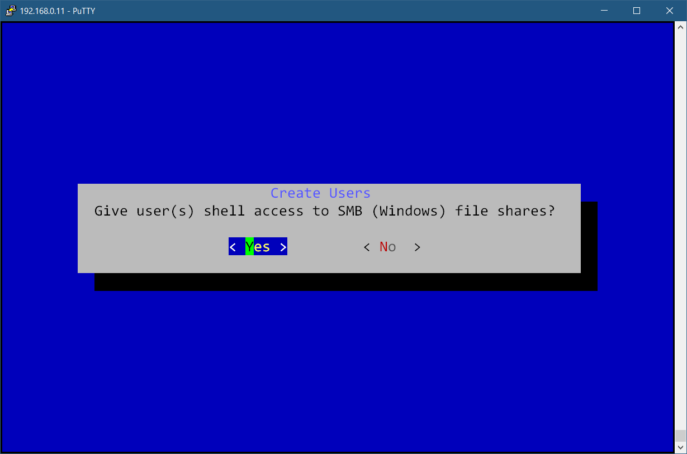
SMB file shares and shell access have a default value of yes. Admin access defaults to no.
You will be given one final chance to bail out before users are created.
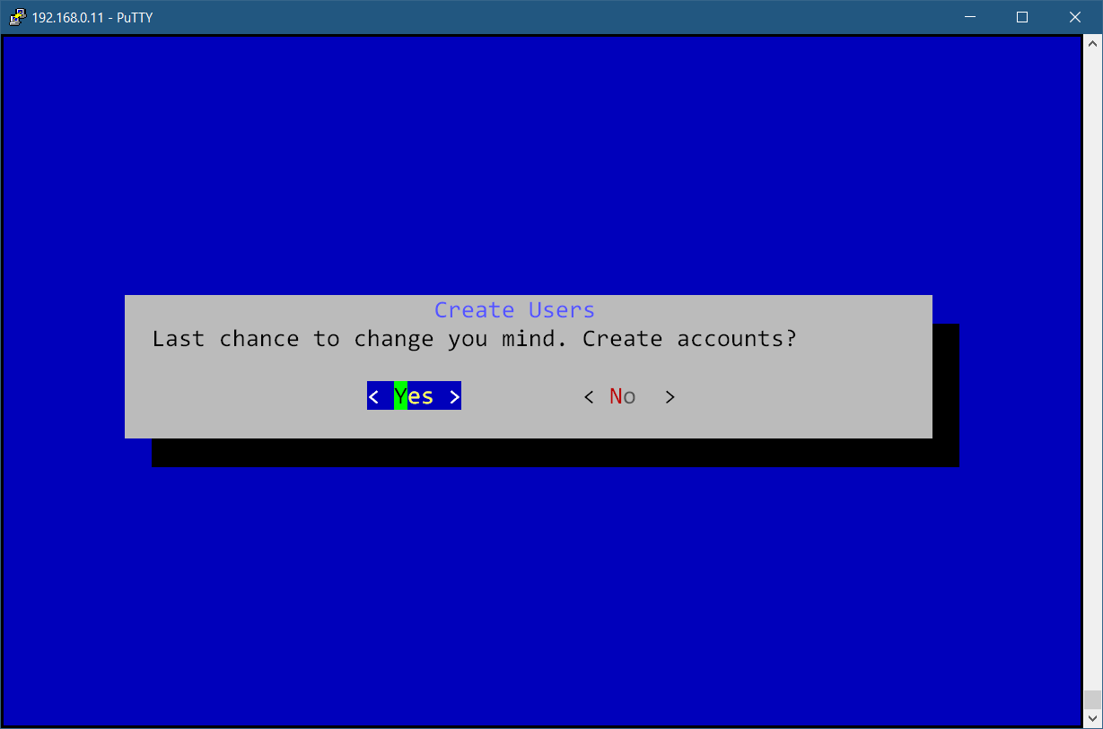
User accounts are assigned a random password. Passwords are not recorded. The system admin will need to log in via ssh and use the smbpasswd command to change file sharing passwords and the passwd utility to change shell account (ssh) passwords.
In the future, users will be able to use a self-service password changing tool.

Self-Service Password Changes
Note: This feature is not implemented at this time.
Users forget passwords all the time. WeeNAS includes a self-service password changing utility that allows users to reset system passwords based on a secret phrase that they have set up.
The password changing utility can be accessed by visiting the WeeNAS URL: https://<hostname>:9000
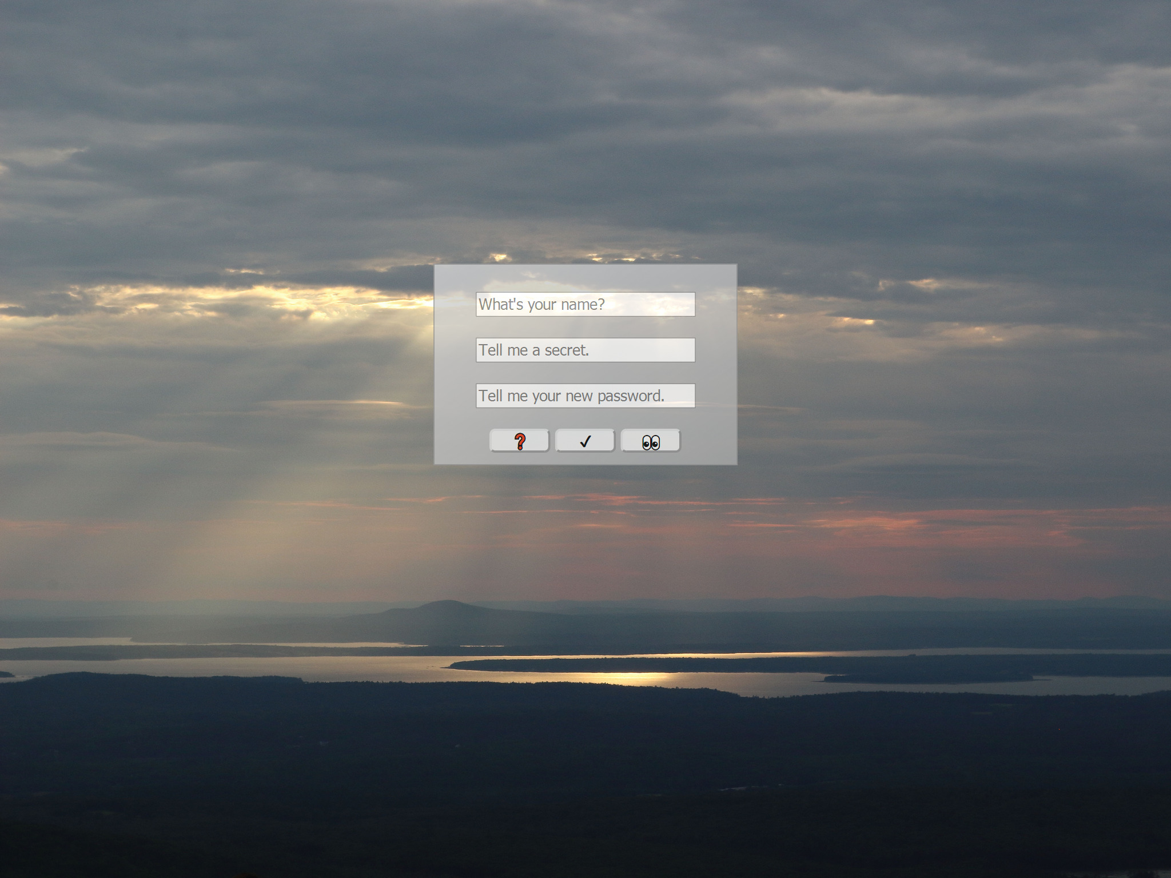
Once there, users will be asked for their login name, a secret, and a password.
On the first visit, there is no secret, so whatever is entered will be recorded. Obviously, this is a security hole, since anyone could enter a login name and create whatever secret and password they want for any user who has not set one up yet.
WeeNAS was designed for small, home network installations where users are trusted, so this is not seen as a flaw, but rather a convenience. For applications needing greater security, setting an impossible to recreate secret for each user will make it harder for a malicious user to abuse the self-service tool.
Secrets are stored in /usr/local/etc/weenas/wnpasswd as a JSON object containing the login name with a SHA-512 hash of the secret phrase.
It looks something like this:
{
"freebsd": "af10a4e247d9fc4d710347dbd75fe6b3394022ece9de67e1ec546c929623f0c0e1bffd5027e3c73d1a9cfd907dfef1d62d111b54012919e43de12c51389113d0"
}
Simply adding a user with a hash of ‘x’ is enough to prevent using the self-service password tool. No phrase will ever generate a SHA-512 hash of ‘x’.
Here’s an example:
{
"freebsd": "af10a4e247d9fc4d710347dbd75fe6b3394022ece9de67e1ec546c929623f0c0e1bffd5027e3c73d1a9cfd907dfef1d62d111b54012919e43de12c51389113d0",
"dave": "x"
}
Additions to the file are shown as yellow highlights. Note the comma, separating the new entry from the one above, and also the locations of quotes and the colon. If you are not one-hundred percent confident of your JSON skills, use an online JSON validator to check your work.
The changes shown above prevent the user with login account ‘dave’ from using the self-service password tool.
It is important to note that the secret pass phrases used for self-service resets are also used to log into the WeeNAS administration tool. In this case, ‘dave’ is not only blocked from making self-service password changes, but the account is also blocked from accessing the WeeNAS admin page.

Changing the Wallpaper Image
If, for whatever reason, you are not satisfied with the tranquility of the sunset image included as the standard WeeNAS admin wallpaper, you can change it. Find any large image that strikes your fancy and save it as /usr/local/share/weenas/htdocs/wallpaper.jpg.
For best results, use an image with landscape orientation, large size and low JPEG quality setting. Using a vacation photo straight from a digital camera is not recommended as it will likely be several megabytes in size and result in slow loading times.
Use a program like GIMP or the Windows Photos app to optimize the image for fast delivery. Eliminating meta information and embedded thumbnails can shrink size without affecting quality. JPEG quality can also be reduced. Aim for a file size of around 1MB. Remember, this is a background wallpaper, not a renaissance masterpiece.

